OUTPUT:

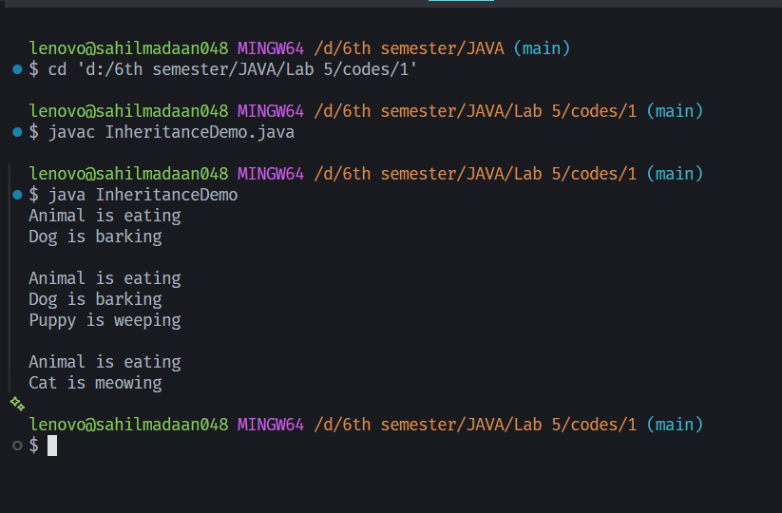

LAB 5
- Write a Java Program to demonstrate all the three types (Single, Hierarchical, & Multilevel) Inheritance.
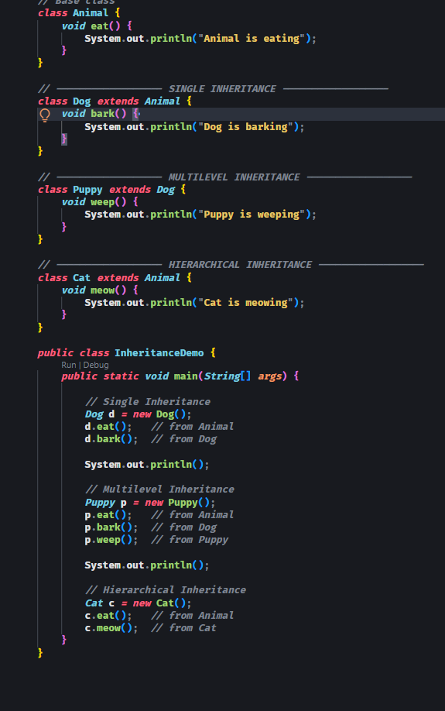

OUTPUT:

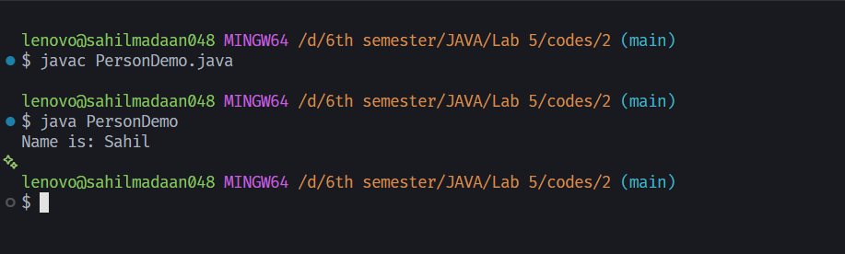

LAB 5
2. Write a Java program to create a class Person with:
Private variable: name
Public methods:
setName(String n)
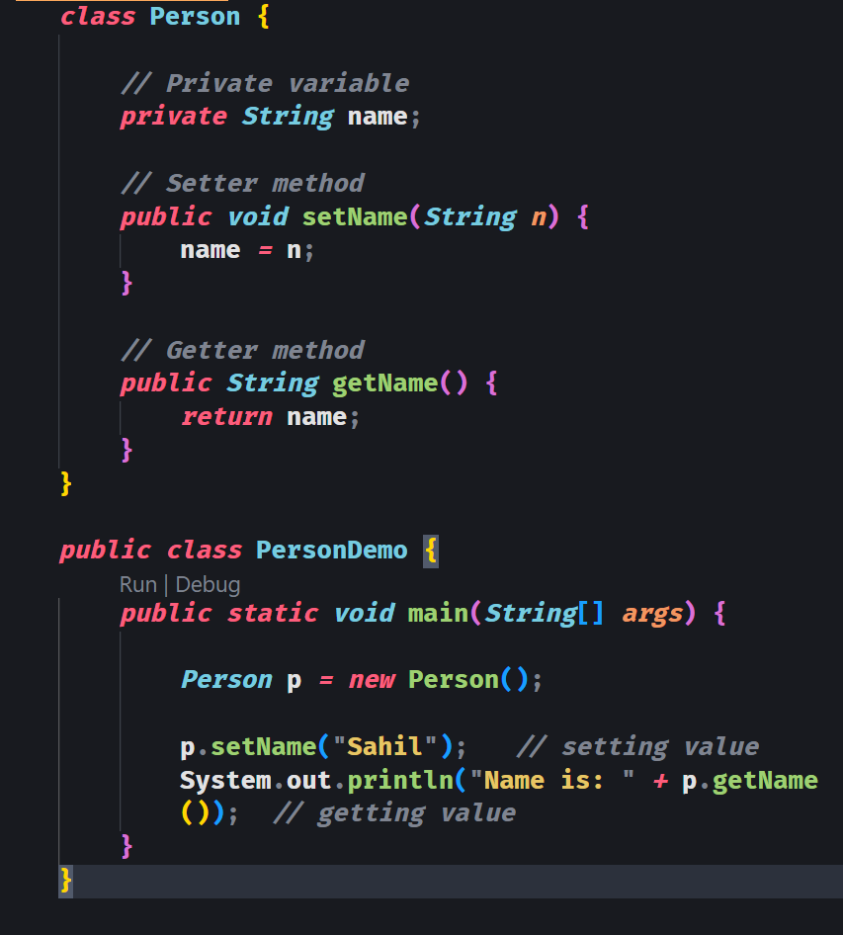
getName()

OUTPUT:
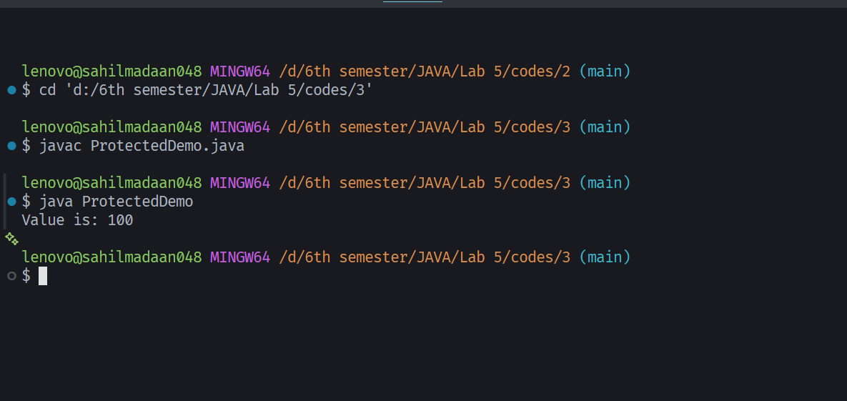

LAB 5
3. Write a Java program to demonstrate protected access modifier:
• Create a class Parent with protected variable value
• Create a subclass Child those accesses and displays the value
Create an object of Child and display the result.
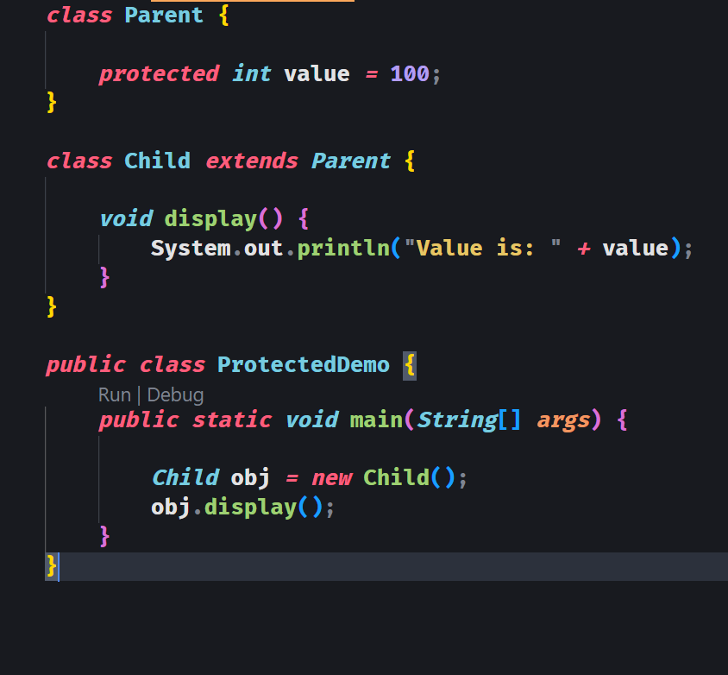

OUTPUT:
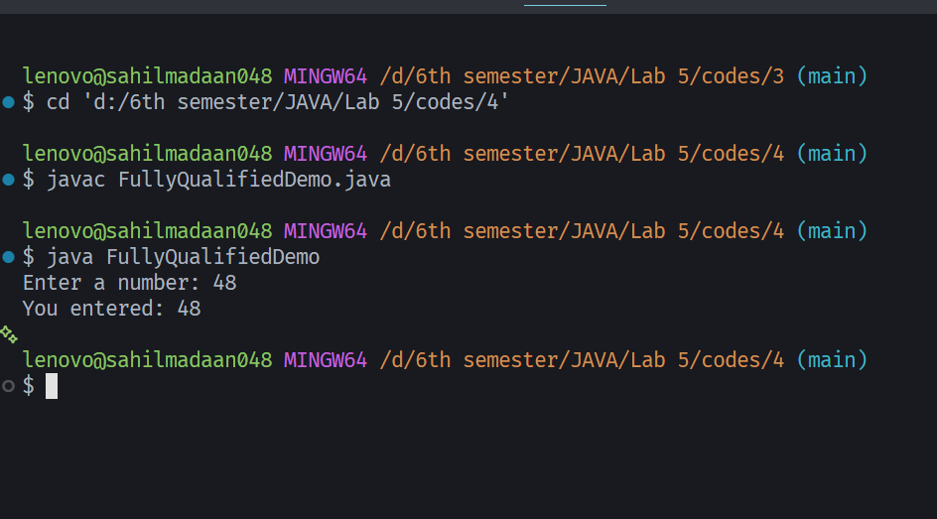

LAB 5
4. Write a Java program to access a class (say Scanner or some userdefined) from a package using fully qualified name without using import statement.

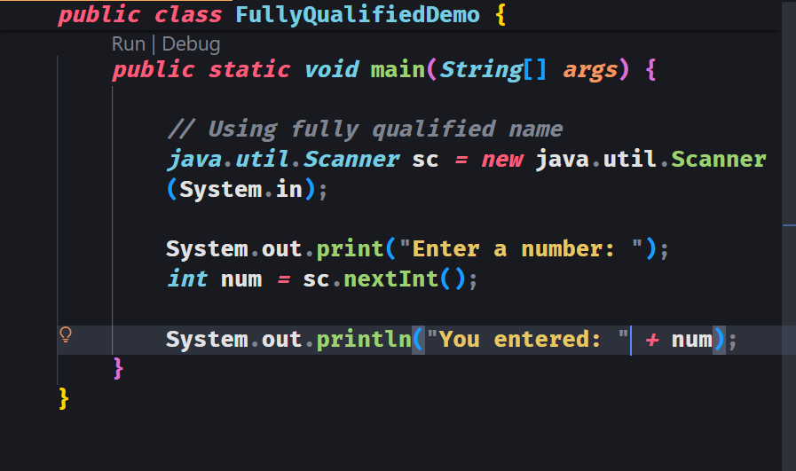

OUTPUT:

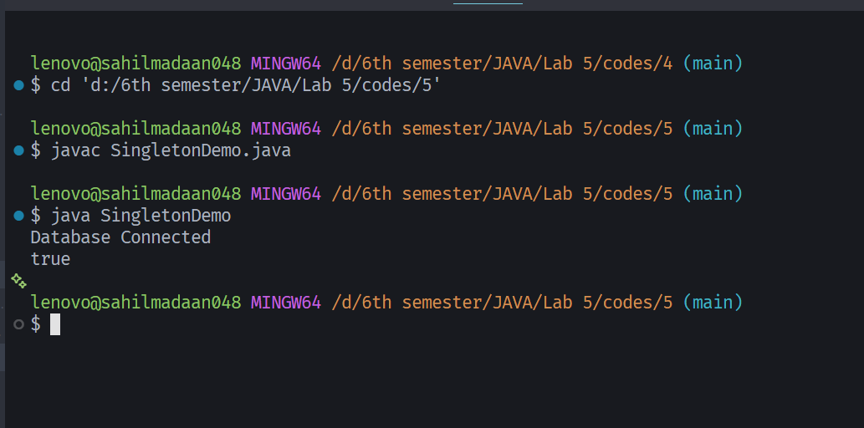

LAB 5
5. Write a Java program to create a class DatabaseConnection that implements the Singleton Design Pattern. The Singleton pattern means that only one object of a class can be created from outside the class.
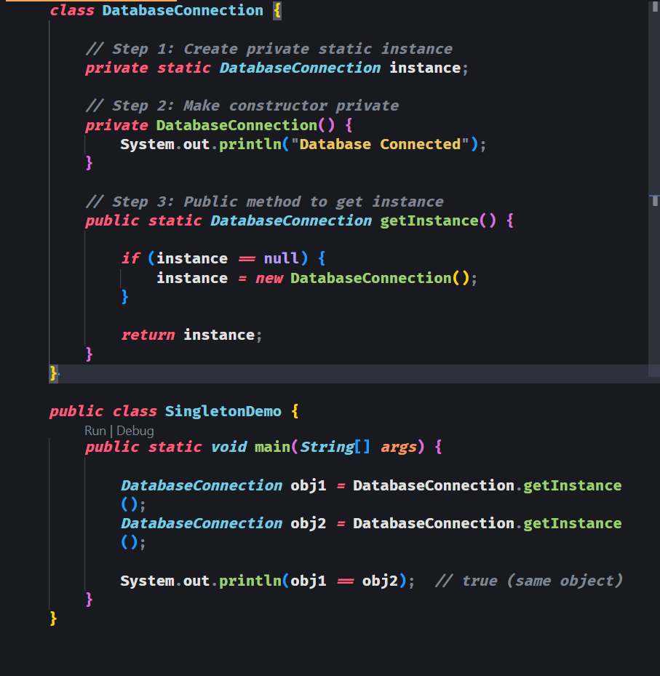

OUTPUT:
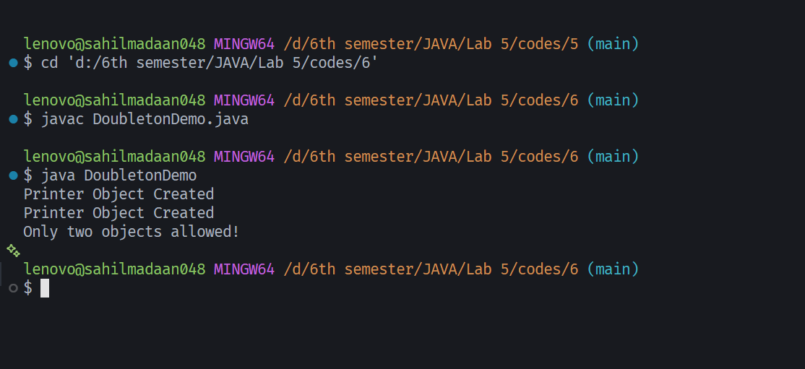

LAB 5
6. Write a Java program to create a class Printer that implements the Doubleton Design Pattern. The Doubleton pattern means that only two objects of a class can be created from outside the class.

